Green Schools Student Committee
Proposals for Coláiste Éinde
To: Mrs. Quinn, Mrs. Hernon | From: Green Schools Student Committee
Terms of Reference:

This report looks at the issues and problems in this school from an environmental point of view, and details some initiatives and solutions which will help transition this school and its community into a healthy and sustainable model for the future.

Contents
Introduction...........................................................................................................3
Green Schools Committee.....................................................................................4
Plastic Bottles and Litter Collection.......................................................................5
Non-Recyclables in the Canteen............................................................................7
Recycling Bins........................................................................................................8
Biodiversity and Environment...............................................................................9
List of Short Term and Medium Term Projects and Initiatives..............................11

Introduction
The Green Schools programme is an internationally recognised initiative aimed at promoting long term environmental management through classroom studies and creating sustainable and positive action plans that can be accomplished within the school and local community.
Through the establishment of the Green Schools student committee here in Coláiste Éinde we are creating a sense of leadership and ownership of initiatives that we believe can make a tangible difference to our local environment and foster a sense of responsibility to students in our school.
We have developed a number of strategies that we feel would be of great benefit to the school and would greatly impact on the environmental ‘footprint’ that all of us have a duty to reduce.
Our initiatives are simple and complex, cheap and costly, easy to run and difficult to implement. We require help to achieve in achieving these goals and have invited all stakeholders in the school; students, teachers, parents, local businesses and community groups, to help us in our quest. We believe, that with your approval and assistance we can help our school to become a more attractive place to attend and change the attitudes of our fellow students to a more positive and caring one for our environment.
Within this report are 4 strategies that we feel can and should be implemented as a priority for the 2016/2017 school term. This report explains the changes that should be made, which will help our school to move into the twenty first century and help break the old habits that our school has adapted over the past few years

Li Lu Savage

Green Schools Committee

Chairperson: Li Lu Savage
Secretary: Paraic O’Reilly
Scribe: Lauren McKiernan
Members: Darragh O’Donohoe,
Naomi Ugbo,
Joyce Mbozo,
Aga Chalecka,
Wisam Yousif,
Georgia Ryan,
Katie Bourke,
Conor Timlin,
Jacub Kosntanski,
Elena Vardanyan,
Keelin O’Donohoe,
Kristers Graudins,
Folasade Olawoye.

Teachers: Mr.Curran, Mrs.Newman, Sr.Pauline.

- Plastic Bottles and Litter Collection
By Jacub Konstanski
Issue:
All over the school indoors and outdoors you can see rubbish and a lot of plastic bottles. This rubbish accumulates in certain areas, especially around the lockers and outside in bushes. A lot of this rubbish is recyclable plastic bottles. As an experiment to look at the quantity of plastic bottles discarded around the school grounds, a second year CSPE class collected over four large bags of plastic bottles in 20 minutes. Plastic bottles are a scourge on the environment and are one of the main contributors to pollution in our seas and over our land as they do not naturally degrade. Rather they release poisonous chemicals which leach into the ground and pollute the water table. They also break down into microplastics in the sea and are ingested by fish, thus entering the food chain.
Solutions:
Our solution is to create a ‘no plastic bottle’ rule in the school. If students wish to bring in a liquid it must be in a reusable bottle. For those who do not have a reusable bottle, B1 and the green school committee designed and created a reusable bottle for students to purchase. As an experiment, 100 bottles were purchased and sold for €5 at lunch break to students. All 100 bottles were sold and the feedback from the students was overwhelmingly positive. For the first years that will be coming to the school next year we want to create a culture of reusability and our recommendation is that this bottle is sold at a discounted rate to these students.
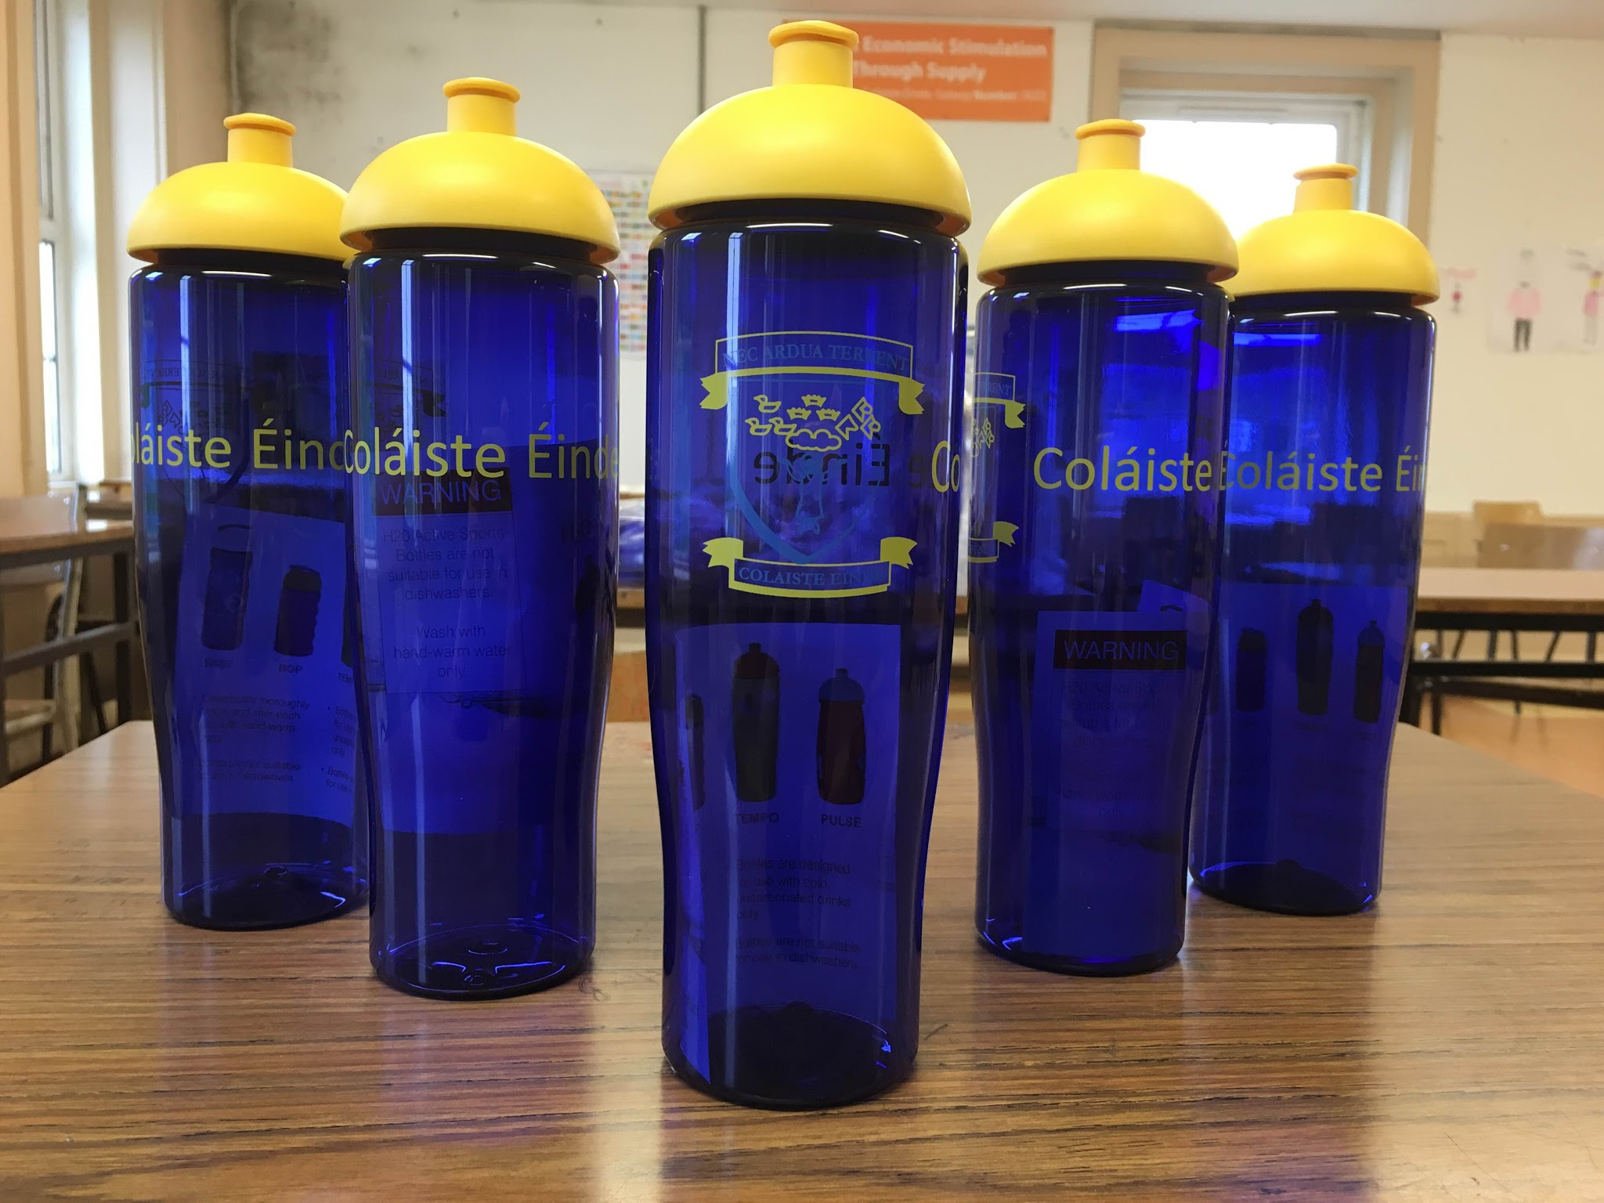

Our second solution is a strategy that has been successfully run in schools all around the country. It involves the student population taking responsibility and action for the litter that they generate. A class rota is created in which a class a day is responsible for picking up rubbish outside the school for 10-15 minutes every day. The class teacher responsible at that time meets the students at 1.45, divides the students into pairs and gives them a bag each in which to collect the rubbish. This will require staff involvement and may be a challenge in the initial stages to iron out any logistical concerns that may arise. However, the benefits to the school will be substantial.
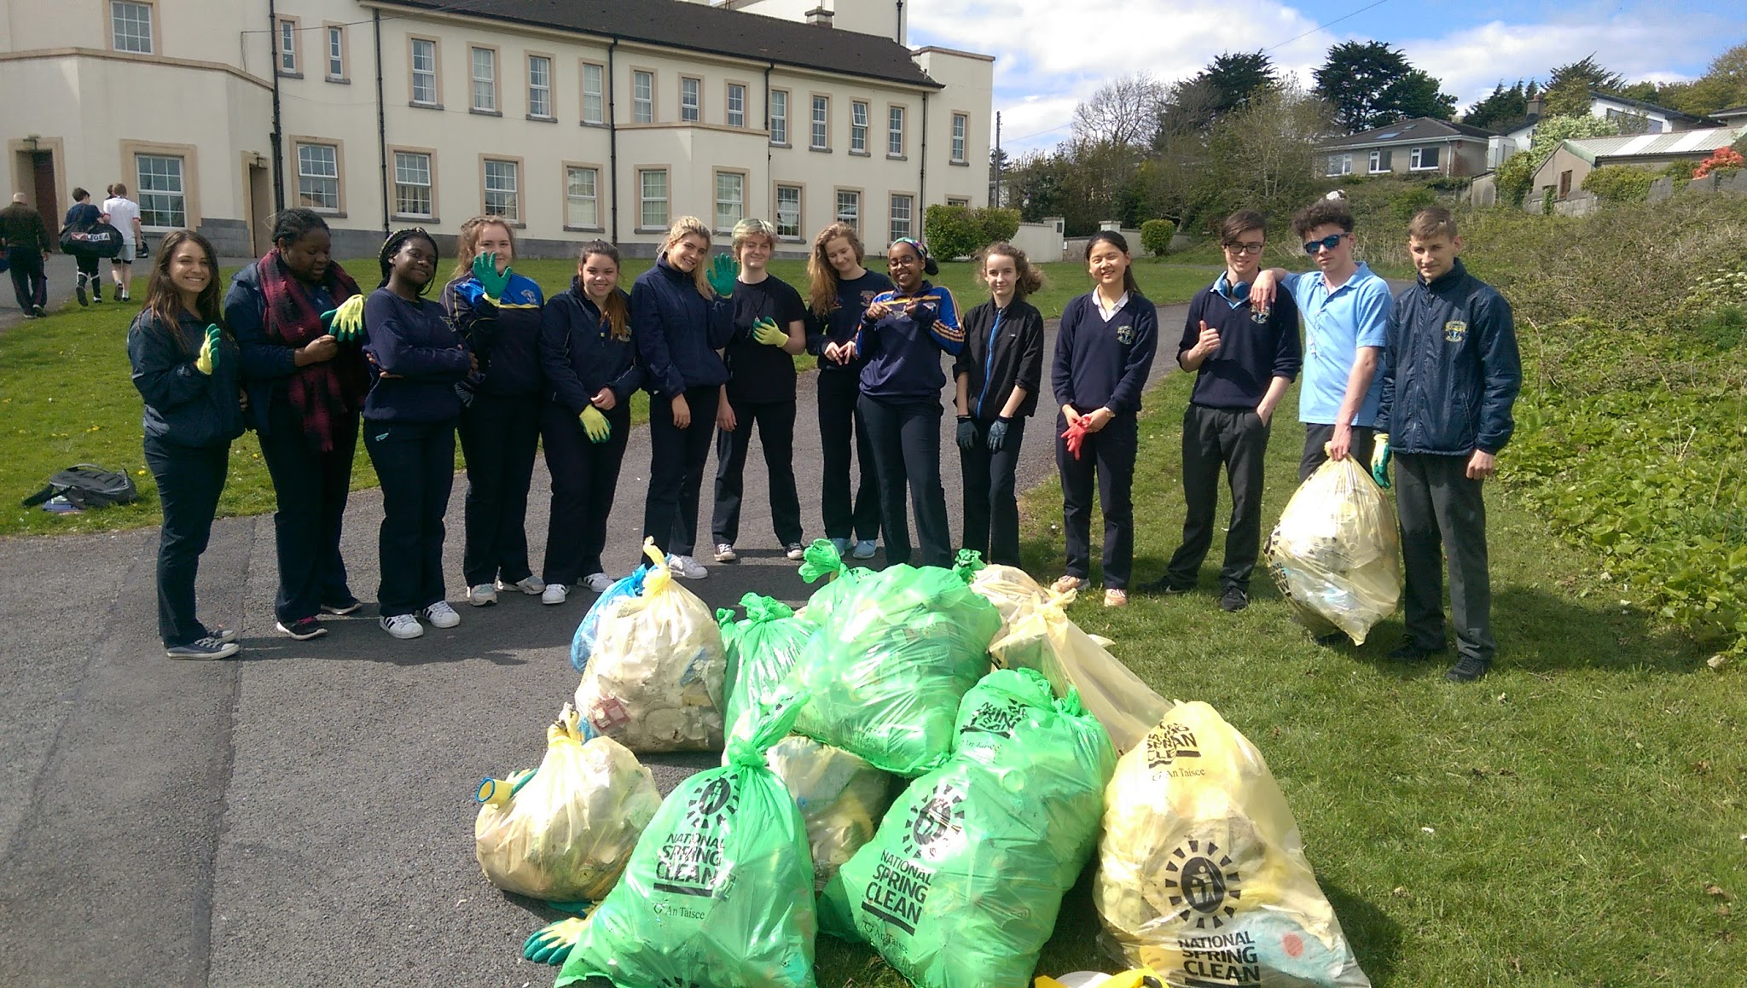

2. Non-recyclables in the Canteen
By Li Lu Savage
Issue:
There are many problems regarding the canteen in Colaiste Einde, which is in the Green School Committees interest to rectify. These problems include:
- The aluminium food containers, plastic cutlery and sandwich containers, provided by the canteen are neither biodegradable nor are they currently recycled.
- There are no recycling bins and waste food is currently not separated for diversion to compost
- Vegan / Vegetarian options are limited.
These problems contribute to the growing problem in this world of pollution and have a knock-on effect of killing wildlife, destroying habitats and contaminating our atmosphere.

Solution:

Despite what we are doing now, we can move forward by:
- Introducing biodegradable lunch containers, utensils and sandwiches bags, available from Musgraves and any other supplier. See www.down2earthmaterials.ie.
- All food waste, biodegradable containers and utensils to be separated and placed in recycling bins provided
- Installation of a clean drinking water fountain, placed in a hygienic area.
- Encouraging the canteen staff to broaden the range of foods to include more Vegan and Vegetarian options, which are not only healthier but kinder to the environment.
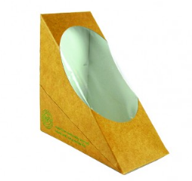
These changes can and will make a difference not only to our school grounds but to our wider community and environment.
3. Recycling Bins
By Paraic O’Reilly
Issue:
Colaiste is a large school with many students. This naturally leads to it having a large output of waste. However, the only means of disposing of rubbish that is available to students is the general waste bins that are scattered around the school. This means all plastics, papers and general waste get disposed of in the same way. This unnecessarily increases Colaiste Einde' s Carbon Footprint. However it is my belief that the amount of recyclable material that is thrown away can easily be reduced with the addition of 8-10 recycling bins around the school.
Solution:
Here are my suggestions for recycling bins that can be easily implemented into the school: The recycling bin I recommend for inside the school is the Nexus® 100 Mixed Recyclables Recycling Bin.
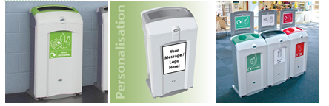
The bin I recommend for use outside in the school grounds is the Nexus® City 240 Mixed Recyclables Recycling Unit. Constructed from double skinned Durapol, the Nexus City 240 Recycling hoods are extremely robust and will withstand heavy use and operator misuse.
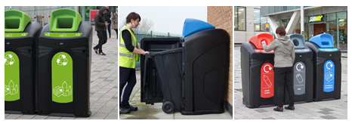
We are currently conducting an audit of the amount of waste generated, and cost to the school and hope to have a full breakdown of figures shortly.
4. Biodiversity and the Environment
By Darragh O’Donohue
Issue:
I am writing a report on the current use of the school’s grounds and how to improve to use of our grounds in an environmentally friendly, yet, cost effective way. The school grounds contain the school building, a football pitch, two outdoor basketball courts, a Gaelic pitch and a rugby pitch. (All of which can be seen below, with the exception of the rugby pitch.) Yet, as shown below, there are many areas of grass or scrub that have been left unused.
Solution:
The Green Schools of St.Enda’s propose the use of these areas as either a natural woodland or an outdoor classroom.
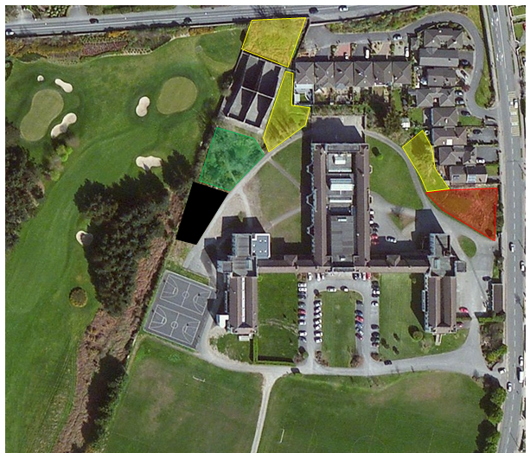
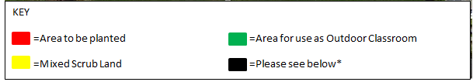
Planted Woodland Area: The area shown above in red holds great possibility for use as a woodland and could be very easily planted with upwards of seventy trees as the space needed, on average, to plant a tree is 4m² and inside the red shaded area there exists c.294m², allowing for almost 74 trees.
Outdoor Classroom: In the space shaded in green there is an unused spot of land that would be perfectly used as an outdoor classroom. The construction of an outdoor classroom’s framework could be a transition year project. This would both be a great experience for the T.Y Students but could also limit cost of building a frame for the outdoor classroom. Potential design ideas shown below.
We have contacted organisations such as the Native Woodland Trust and ChangeX based in the Burren who have expressed a high interest in getting actively involved with these projects at little or no cost to the school. More information will follow as our conversation continues.
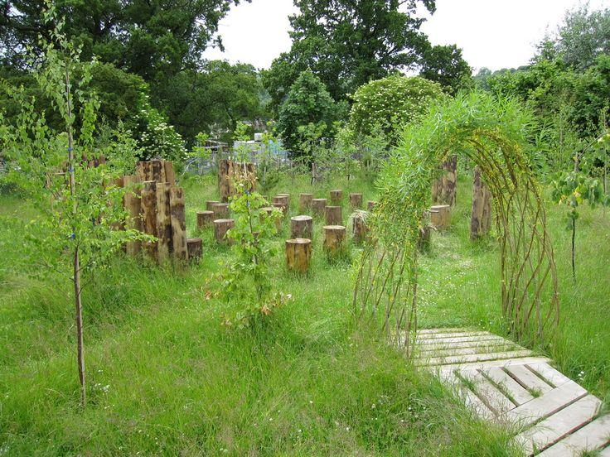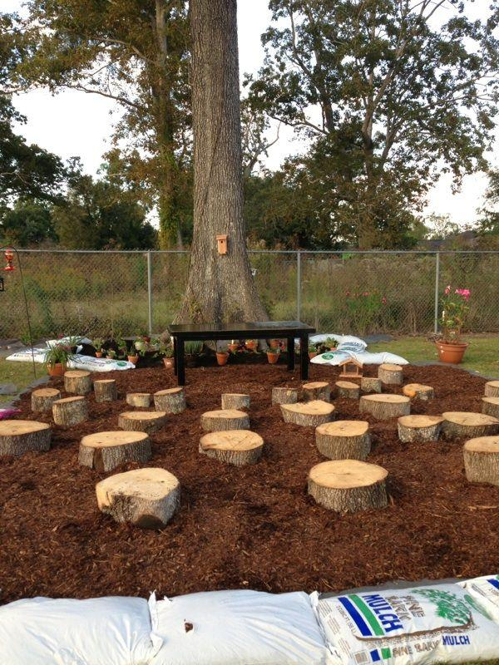

Green Schools Initiatives 2016/2017

Short term projects 2016/2017
- A ban on plastic bottles within the school with reusable bottles mandatory. A branded Colaiste Einde bottle will be available to purchase.
- Scope for planting tens of more trees and flowers.
- New bins required around the pitches, courts, new benches, bathrooms.
- The introduction of a rota between all students after the big break to pick up rubbish outside every day.
- More bicycle spaces and maintenance of sheds.
- More recycling of cardboard with the introduction of sturdy green bins for classrooms and the corridors.
- The introduction of the school app for smartphones will significantly decrease the amount of paper used for communication purposes.
- Increase in the use of IT amongst teachers to decrease the use of paper.
Long Term and capital projects 2016 +
- A phasing out of plastic packaging and styrofoam in the canteen.
- An increase in the vegetarian options in the canteen including salads, smoothies, soup etc.
- The installation of drinking fountains in the school corridors.
- Outdoor classroom beside the alleys
- The creation of a vegetable and herb garden adjacent to astroturf with composting bins.
- A kill switch for the power in the computer labs.
- Recreational area including outdoor gym equipment and swings to encourage students to exercise outdoors during the lunch breaks.
- Solar panel installation during the refurbishment of the school roof.
- Windmill and energy storage solutions.

